OFFICIAL COORDINATION REQUEST FOR
NON-ROUTINE OPERATIONS AND MAINTENANCE

COORDINATION TITLE- 15BON75 BI winter maintenance begins two weeks early
COORDINATION DATE- 8 September 2015
PROJECT- Bonneville Lock and Dam
RESPONSE DATE- 30 September 2015

Description of the problem - Bonneville project would like to request an extra two weeks for the 2015/16 winter maintenance period to repair FV4-3 and FV1-1 in the Bradford Island adult fish ladder. In previous years, two valves have needed repairs within critical fish passage times, Bonneville would like to repair this valve (FV4-3) and the component that supplies water for the collection channel diffusers (FV1-1).

Type of outage required - Complete dewatering of B-branch, below tailwater

Impact on facility operation - Dewatered two weeks earlier than normal

Dates of impacts/repairs - Orifice flow on 15 November 2015-February 29, 2016.

Length of time for repairs - About 2 weeks prior to regular outage

Expected impacts on fish passage
Downstream migrants - Minimal impacts on downstream migrating fish due to the Ice & Trash Sluiceway gates open and juvenile fish passage has all but concluded by mid-November. In addition, PH2 will be operating per FPP criteria and be the priority powerhouse.

Lamprey - occurs outside lamprey migration season.

Upstream migrants – There have been few bull trout reported during this time but any present would experience similar impacts as upstream migrating salmonids. Table 1 shows the 11-year average for daily passage of salmonids. In mid-November fewer than 200 salmonids pass Bonneville dam and the total number continues to decline as we move later into the month. With the Washington Shore fishway remaining in FPP critieria and PH2 remaining the priority powerhouse, minimal impacts will be expected for those fish attempting to pass at Bradford Island. Taking the ladder down early and allowing for more extensive maintenance to occur on the fish valves will help ensure there are fewer impacts to those fish using that ladder during the fish passage season.

Table 1. BON Adult salmonid average passage numbers for 2004 – 2014.

Table 2. BON Outflow average for 2005-2014.

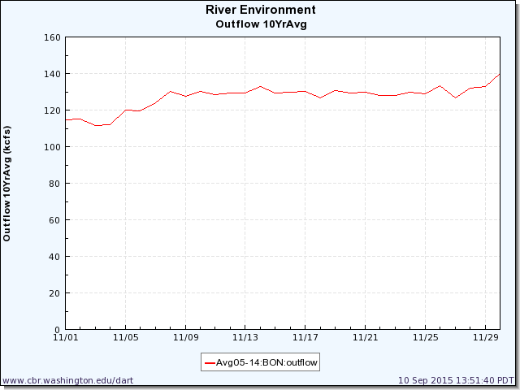
Figure 1. Bon Outflow 2005-2014 Avg.
DART Data Citation
Columbia River DART, Columbia Basin Research, University of Washington. (2015). River Environment Graphics & Text. Available from http://www.cbr.washington.edu/dart/query/river_graph_text

Table 3. Bon OOS (out of service) Units

Comments from agencies

Final results

Please email or call with questions or concerns.
Thank you,
Karrie

Karrie Gibbons
NWP Operations Division Fishery Section
Columbia River Coordination Biologist
503.779.6131
Karrie.M.Gibbons@usace.army.mil

